LOGIC LAB EXPERIMENT 1 REPORT

  - Introduction
This experiment was conducted to demonstrate that Vivado simulations of the designed modules align with the BASYS-3 FPGA board. The primary objective was to find the most cost-effective version of a specific function, implement it, and validate the simulation results through hardware testing. This process was essential for understanding the complete FPGA and Verilog design flow with BASYS-3.

  - Materials and Methods
To simplify the given function , we used Quine-McCluskey method on the paper. After simplifying the function we used Vivado 25.2 to implement and simulate our simplified function. While implementing , at first we designed necessary gates ; after necessary gates , we set up the minterms of the simplified function and we put all minterms together.

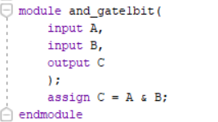
As illustrated in Figure 1, a logic function was derived to map two inputs, A and B, to an output C. The functional requirements are defined as follows:
- For A = 0 and B = 0, C = 0 > * For A = 1 and B = 0, C = 0 > * For A = 1 and B = 1, C = 1

Figure 1
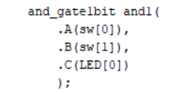
Figure 2
As shown in Figure 2, the two inputs were converted into minterms using the previously derived gate module. The implementation is defined by the logic:
- LED[0] = sw[0] & sw[1].
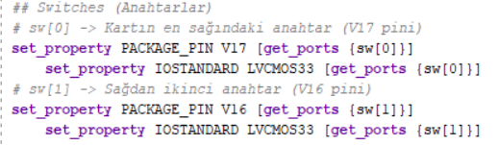
Figure 3
The variables sw[0] and sw[1] utilized in Figure 2 were mapped to the corresponding hardware input pins of the BASYS 3 board.

Simulation part also conducted on Vivado 25.2 , we have tried approximetely %90 of all input combinations on the simulation part. A simulation input structure written by us have given correct results as we expected. After approving the simulation results , the bitstream code is generated on Vivado 25.2. Generated bitstream code uploaded to BASYS 3 FPGA board and the simulation results and the observations on the FPGA board were the same.

  - Results
All of the circuits implemented in the project, which include the basic logic gates and the combined minimized combinational logic function, were hardware-tested and simulated.
Basic Logic Gates
We simulated the three basic 1-bit logic gates (AND, OR, Not) using the simulation tools that are built into the program. We tested all possible combinations and found that our output matched the theoretical truth tables for the gates.
Once all gates were verified by simulation, the modules were programmed onto the FPGA. The gates were used as follows, with switches sw[0] and sw[1] as inputs and LEDs LED[2] through LED[0] used for output. Each combination of input would give me the same output as simulated. Therefore, the hardware behaved as expected.
Minimized Combinational Logic Circuit (Gate-Level Implementation)
The minimized Boolean function from the minimization process was realized using previously-built AND, OR, and Not gate modules and were simulated before being programmed onto the FPGA.
We recorded output from the circuit and input combinations from all inputs. Our measured values matched the expected output based on the truth table generated from the minimized Boolean expression.
  - 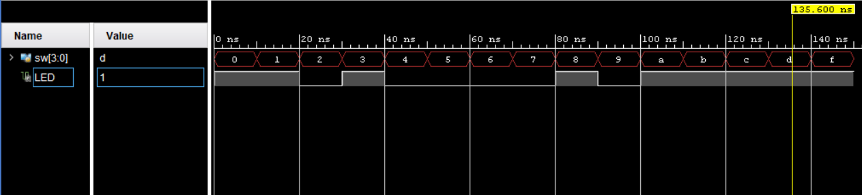
Figure 4 Gate-Level implementation simulation results
  - Minimized Combinational Logic Circuit (Assign Statement Implementation)
The same Boolean function was implemented using a single Verilog assign statement. Simulation and FPGA testing were repeated.
The observed outputs of the assign-based implementation were identical to those obtained from the gate-level implementation.
Comparison with Expected Values
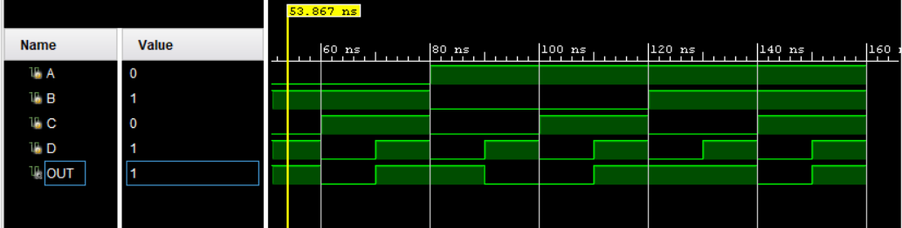
Figure 5 Assign statement implementation simulation results
For all defined minterms, the outputs produced by both implementations matched the theoretical results. For input combinations corresponding to don’t-care conditions (ϕ), the observed outputs were consistent within each implementation but were not constrained by the original function specification.
Truth tables of observed and expected outputs are provided in the report figures and tables.
  - Discussion
The findings of the experiment support the predicted results for the logic gates and combinational circuit based on logic minimization.

The three modules had their correct outputs shown in both the simulation and on the FPGA, therefore proving that all three modules were correctly designed and successfully synthesized, and that proper pin mapping was used, which also proves the FPGA correctly implements the Verilog coded combinational logic.

Both methods of implementing the minimized Boolean function from the minimal representation, that is, from gate-level design versus single line assign statement provided the same functional behavior of the Boolean function. This shows that two different structural representations of the same Boolean function can synthesize into functionally equivalent hardware.
Behavior of Don’t-Care (ϕ) Inputs
The original Boolean function included don’t-care terms. These input combinations are not required to produce a specific output and may be assigned either 0 or 1 during logic minimization.
During synthesis, the FPGA optimization tools assign values to these don’t-care cases in a way that minimizes hardware cost, reduces logic complexity, or improves timing performance. As a result, the implemented circuit may produce outputs for don’t-care inputs that differ from other logically valid implementations, but still remain correct because those outputs are not constrained by the original function definition.
In this experiment, the observed outputs for don’t-care input combinations were determined by the simplified expression produced during minimization and by synthesis optimization. Therefore, these outputs are expected and valid.
Implementation and Testing Observations
The following technical aspects had to be considered for successful hardware simulation and implementation of device (FPGA) system. These include:
- Correctly connecting the ports of each of the modules.
- Correctly mapping the LEDs and switches on the FPGA board.
- Verifying that the waveforms output from your simulation matched the output of the device.
- The logic will be consistent between the two methods shown above, (structural vs. behavioral).
After verifying your simulation you will produce a "bitstream" that you will upload to the FPGA, where the hardware produced should visually match what was produced in the simulation.
Some minor timing differences exist because the hardware's propagation delay is typically longer than that of digital logic and do not create a logical error.
Overall, the experiment demonstrates the complete digital design flow: logic minimization, hardware description, simulation, synthesis, and physical implementation.
  - Conclusion
The scope of the study was completed successfully. The basic combination logic gates were designed, and tested both by simulation and on the FPGA hardware. The minimal Boolean function was created and implemented using both a gate-level implementation of the function as well as using a direct assign statement in Verilog.

The theoretical and experimental values matched at each of the tested points. This experiment confirmed and reinforced knowledge gained through working with the combinatorial design process of Boolean function minimization in Verilog, programming a FPGA, and verifying the hardware.

The experiment further illustrated how synthesis tools will consider don’t-care states in order to optimize the actual implementation of a circuit. Overall the lab offered the opportunity to gain hands-on experience implementing a complete digital design using FPGA technology.

  - References
[1] BLG 242E Experiments Booklet, Istanbul Technical University.
[2] Course lecture slides and laboratory instructions.
[3] FPGA development board datasheet.
[4] Verilog HDL reference materials and software documentation.

